**Lab 5: Thevenin – Norton Equivalent**

**Objective:**

To demonstrate equivalent circuits using computer simulations and actual circuits. Students should gain additional experience using computer simulations tools.

**Equipment and Components:**

1. DC Power Supply
2. Digital Multimeter
3. Breadboard
4. Resistors: 5.1 kΩ, 13 kΩ, 20 kΩ, 24 kΩ, 43 kΩ, 56 kΩ, 120 kΩ, plus any additional ones from your design.
5. Multisim or any SPICE simulation software

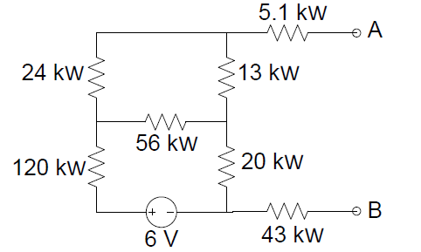

Figure 5.1: Circuit to be analyzed

**Preliminary:**

Using the circuit shown in Figure 5.1:

1. Calculate the Thevenin and Norton equivalent circuit by using the following analysis:

1. Find the open circuit voltage (Voc) using node analysis.
2. Find the short circuit current (Isc) using mesh analysis.
3. Calculate the Thevenin or Norton equivalent resistance using Voc and Isc. (Req = Voc / Isc)
4. Suppress the source and use resister combinations to find Req. Does this match part c?

2. Use Multisim (or any simulation software) to determine the Thevenin and Norton equivalent circuits using the two different methods described below. Include the simulation output in you lab book.

1. Use Multisim and find the open circuit voltage (Voc) and short circuit current (Isc). From those two values, calculate the Thevenin or Norton equivalent resistant (Req = Voc/Isc).

***Note:*** *SPICE simulators cannot handle floating nodes and only returns branch/element voltages and currents. You must insert a “very large” and/or “ very small” resistor as the loads in order to gain load type information.*

* To find **VTh**, we need to evaluate the open circuit voltage between terminals A&B. Add a very big resistor e.g. Rload = 1x 101012Ω which is the approximate resistance of air, (represented as 1E+12 in SPICE format) between terminals A and B to represent an open and find the voltage. Make sure to ground terminal B. You can use .op analysis and note the voltage difference between A&B or you can place probe on terminal A and run transient analysis.
* To find Ioc, short the input terminals A & B (i.e. connect a wire between them) and using a probe, measure the current through the load.

***Warning:*** *When dealing with the extreme values keep in mind that the resulting matrixes may be ill-conditioned. Verify that the final answers do not violate KCL / KVL rules. If this is a problem try relocating the ground.*

1. Suppress the power supply (replace it with a short – 0V) and apply a test voltage = 1V between terminals A & B. Determine the current flowing into the circuit. The equivalent resistance can be found by Req = Vtest /Iforced.
2. Include in your lab book, schematics of the Thevenin and Norton equivalent circuits.

**Procedure:**

1. Create the circuit shown in Figure 5.1 on a prototyping board.

2. Measure the open circuit voltage (Voc) using a voltmeter and calculate the Thenvenin equivalent voltage source.

3. Measure and calculate the equivalent source resistance using the following two methods:

a. Suppress the voltage source in the circuit (replace it with a short circuit) and measure the input resistance (between terminals A and B).

***Remember:*** *When using a multimeter to measure resistances, all other source must be removed or the resulting values will be erroneous. This can complicate any circuit that requires a bias voltage, like transistors and op-amps. What reading do you get on the multimeter if the voltage source is NOT suppressed?*

b. Suppress the voltage source in the circuit and attach a test voltage source to the output. Measure the forced current that follows into the circuit with an ammeter. Calculate the effective resistance of the circuit using Vtest and Iforced.

***Note:*** *We could also measure the short circuit current (Isc) and calculate Req using the Voc and Isc. However, in practice it is a bad idea to short the output terminals of any random circuit. Before shorting any terminals, users must verify that the internal circuitry of the system can dissipate the resulting power. Hence, we are not using this method to determine the Req.*

4. Attach the following load resistors to the circuit in Figure 5.1 one at a time. Measure the voltage drop across the load resistor. Calculate the power dissipated by the load resistors. Display all results in a table.

a. A match load (RL = RTh)

b. A resistor half the value of RTh

c. A resistor 2 times the value of RTh

5. Create the Thevenin equivalent circuit of preliminary part 3. Attach the same load resistors from procedure part 4 and measure the voltage, and calculate the power associated with each resistor. Display all results in a table.

**Conclusion:**

1. Compare the calculated values, simulated values, and all measured values.
2. How do the various methods for measuring **RTh** compare?
3. Which method was simplest and most accurate?
4. How did your equivalent circuit and the original circuit compare in regards to the power delivered to the load?